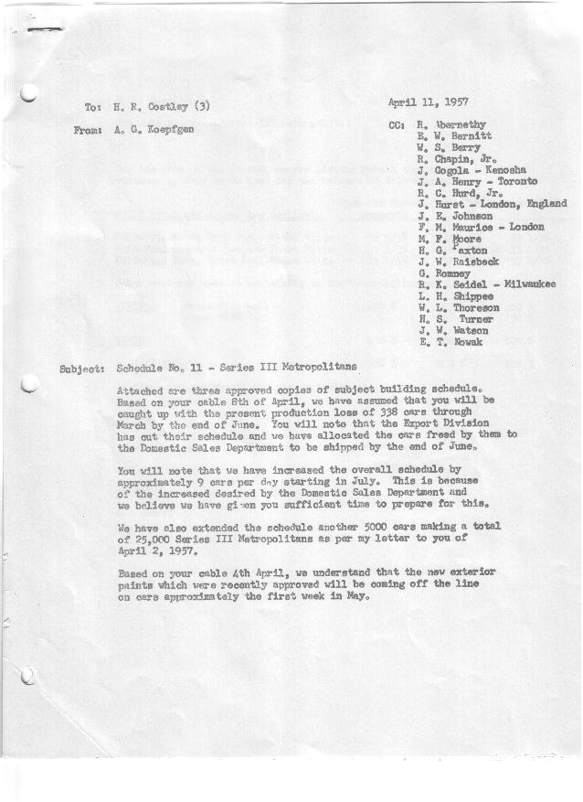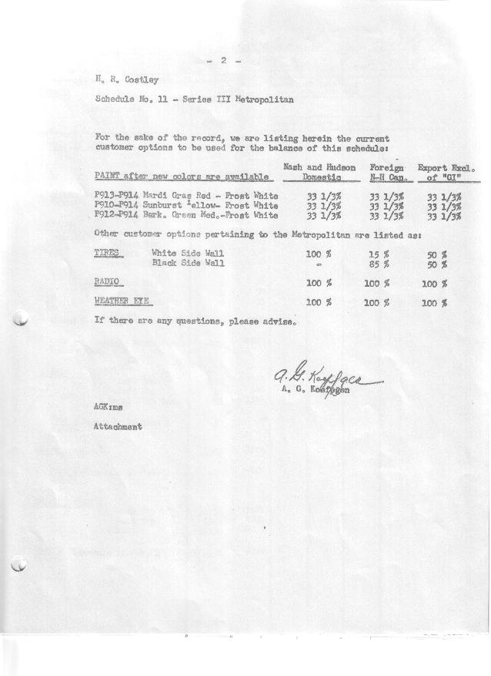

FORM PLAN 68 REV. 2-55-A.M.P Page 1 of 2 APPROVED R. Abernethy (signed) DATE 4/10/57

SCHEDULE NO. ______11 ___ DATE 4/9/57 MONTHLY BUILDING SCHEDULE APPROVED E.W. Bernitt (signed)) DATE_ 4/11 /57 _
REVISION NO. _______ _ _____ DATE PRODUCT APPROVED R.W. Chapin Jr. (signed) ___ _DATE _ 4/11/57 ____
SERIES III 1500 c.c. ENGINE
METROPOLITAN SERIES CARS – AUSTIN MOTORS CO., LTD, ENGLAND
DESCRIPTION | BUILT  ◻ACTEST  THRU  3/31/57 | FIRM BUILDING SCHEDULE  (FABRICATED MATERIAL RELEASE) |  |  |  |  |  |  |  |  |  |  |  |  |  |  | TENTATIVE SCHEDULE  (RAW MATERIAL RELEASED) |  |  | GRAND  TOTAL
DESCRIPTION | BUILT  ◻ACTEST  THRU  3/31/57 | MONTH April  DAYS 20 |  |  | MONTH May  DAYS 23 |  |  | MONTH June  DAYS 18 |  |  | MONTH July  DAYS 20 |  |  | MONTH August  DAYS 15 |  |  |  |  |  | GRAND  TOTAL
DESCRIPTION | BUILT  ◻ACTEST  THRU  3/31/57 | DAILY | MONTH | CUM’L  TOTAL | DAILY | MONTH | CUM’L  TOTAL | DAILY | MONTH | CUM’L  TOTAL | DAILY | MONTH | CUM’L  TOTAL | DAILY | MONTH | CUM’L  TOTAL | DAILY | MONTH | CUM’L TOTAL | GRAND  TOTAL
DOMESTIC LHD:
Hard-Top | 10051 |  | 1040 | 11091 |  | 1222 | 12313 |  | 934 | 13247 |  | 880 | 14127 |  | 660 | 14787
Soft-Top | 1139 |  | 300 | 1439 |  | 406 | 1845 |  | 258 | 2103 |  | 120 | 2223 |  | 90 | 2313
Total U.S. | 11190 | 67.0 | 1340 | 12530 | 70.8 | 1628 | 14158 | 66.2 | 1192 | 15350 | 50.0 | 1000 | 16350 | 50.0 | 750 | 17100
Over/(Under) Schedule 10 Rev1 | (122) |  | 102 | (20) |  | (185) | 165 |  | 66 | 231 |  | 191 | 422 |  | 194 | 616
FOREIGN:
EXPORT LHD Hard-Top | 462 |  | 55 | 517 |  | 70 | 587 |  | 65 | 652 |  | 70 | 722 |  | 70 | 792
Soft-Top | 207 |  | 26 | 233 |  | 20 | 253 |  | 35 | 288 |  | 35 | 323 |  | 35 | 358
Total Export LHD | 669 |  | 81 | 750 |  | 90 | 840 |  | 100 | 940 |  | 105 | 1045 |  | 105 | 1150
RHD Hard Top | 0 |  | 15 | 15 |  | 10 | 25 |  | 10 | 35 |  | 10 | 45 |  | 10 | 55
Soft Top | 0 |  | 7 | 7 |  | 6 | 13 |  | 6 | 19 |  | 6 | 25 |  | 5 | 30
Total Export RHD | 0 |  | 22 | 22 |  | 16 | 38 |  | 16 | 54 |  | 16 | 70 |  | 15 | 85
Grand Total Export | 669 |  | 103 | 772 |  | 106 | 878 |  | 116 | 994 |  | 121 | 1115 |  | 120 | 1235
Over/(Under) Schedule 10 Rev1 | (123) |  | (39) | (162) |  | (34) | (196) |  | (35) | (231) |  | (28) | (259) |  | (28) | (287)
CANADA Hard-Top | 1245 |  | 205 | 1450 |  | 100 | 1550 |  | 123 | 1673 |  | 60 | 1733 |  | 60 | 1793
Soft-Top | 46 |  | 42 | 88 |  | 52 | 140 |  | 8 | 148 |  | 0 | 148 |  | 0 | 148
Total Nash-Can. | 1291 |  | 247 | 1538 |  | 152 | 1690 |  | 131 | 1821 |  | 60 | 1881 |  | 60 | 1941
Over/(Under) Schedule 10 Rev1 | (93) |  | 27 | (66) |  | 10 | (56) |  | 56 | 0 |  | 0 | 0 |  | 0 | 0
TOTAL FOREIGN | 1960 | 17.5 | 350 | 2310 | 11.2 | 258 | 2568 | 13.7 | 247 | 2815 | 9.1 | 181 | 2996 | 12.0 | 180 | 3176
Over/(Under) Schedule 10 Rev1 | (216) |  | (12) | (228) |  | (24) | (252) |  | (21) | (231) |  | (28) | (259) |  | (28) | (287)
GRAND TOTALS
Hard-Top | 11758 | 65.7 | 1315 | 13073 | 61.0 | 1402 | 14475 | 62.9 | 1132 | 15607 | 51.0 | 1020 | 16627 | 53.3 | 800 | 17427
Soft-Top | 1392 | 18.8 | 375 | 1767 | 21.0 | 484 | 2251 | 17.0 | 307 | 2558 | 8.1 | 161 | 2719 | 8.7 | 130 | 2849
Total | 13150 | 84.5 | 1690 | 14840 | 82.0 | 1886 | 16726 | 79.9 | 1439 | 18165 | 59.1 | 1181 | 19346 | 62.0 | 930 | 20276
Over/(Under) Schedule 10 Rev1 | (338) |  | 90 | (248) |  | 161 | (87) |  | 87 | 0 |  | 163 | 163 |  | 166 | 329

FORM PLAN 68 REV. 2-55-A.M.P Page 2 of 2 APPROVED R. Abernethy (signed) DATE 4/10/57

SCHEDULE NO. ______11 ___ DATE 4/10/57 MONTHLY BUILDING SCHEDULE APPROVED E.W. Bernitt (signed)) DATE_ 4/11/57 _
REVISION NO. _______ ______ DATE PRODUCT APPROVED R.W. Chapin Jr. (signed) ___ _DATE _ 4/11/57 ____
SERIES III 1500 c.c. ENGINE
METROPOLITAN SERIES CARS – AUSTIN MOTORS CO., LTD, ENGLAND
DESCRIPTION | BUILT  ◻ACT◻EST  THRU | FIRM BUILDING SCHEDULE  (FABRICATED MATERIAL RELEASE) |  |  |  |  |  |  |  |  |  |  |  |  |  |  | TENTATIVE SCHEDULE  (RAW MATERIAL RELEASED) |  |  | GRAND  TOTAL
DESCRIPTION | BUILT  ◻ACT◻EST  THRU | MONTH September  DAYS 21 |  |  | MONTH October  DAYS 23 |  |  | MONTH November  DAYS 21 |  |  | MONTH December  DAYS 16 |  |  | MONTH  DAYS |  |  |  |  |  | GRAND  TOTAL
DESCRIPTION | BUILT  ◻ACT◻EST  THRU | DAILY | MONTH | CUM’L  TOTAL | DAILY | MONTH | CUM’L  TOTAL | DAILY | MONTH | CUM’L  TOTAL | DAILY | MONTH | CUM’L  TOTAL | DAILY | MONTH | CUM’L  TOTAL | DAILY | MONTH | CUM’L TOTAL | GRAND  TOTAL
DOMESTIC LHD:
Hard-Top |  |  | 924 | 15711 |  | 1012 | 16723 |  | 924 | 17647 |  | 681 | 18328
Soft-Top |  |  | 126 | 2439 |  | 138 | 2577 |  | 126 | 2703 |  | 75 | 2778
Total U.S. |  | 50.0 | 1050 | 18150 | 50.0 | 1150 | 19300 | 50.0 | 1050 | 20350 | 47.3 | 756 | 21106
Over/(Under) Schedule 10 Rev1 |  |  | 1028 | 1644 |  | 1150 | 2794 |  | 1050 | 3844 |  | 756 | 4600
FOREIGN:
EXPORT LHD Hard-Top |  |  | 70 | 862 |  | 80 | 942 |  | 80 | 1022 |  | 96 | 1118
Soft-Top |  |  | 35 | 393 |  | 40 | 433 |  | 40 | 473 |  | 39 | 512
Total Export LHD |  |  | 105 | 1255 |  | 120 | 1375 |  | 120 | 1495 |  | 135 | 1630
RHD Hard Top |  |  | 10 | 65 |  | 10 | 75 |  | 9 | 84 |  | 8 | 92
Soft Top |  |  | 4 | 34 |  | 4 | 38 |  | 4 | 42 |  | 4 | 46
Total Export RHD |  |  | 14 | 99 |  | 14 | 113 |  | 13 | 126 |  | 12 | 138
Grand Total Export |  |  | 119 | 1354 |  | 134 | 1488 |  | 133 | 1621 |  | 147 | 1768
Over/(Under) Schedule 10 Rev1 |  |  | 119 | (168) |  | 134 | (34) |  | 133 | 99 |  | 147 | 246
CANADA Hard-Top |  |  | 75 | 1868 |  | 60 | 1928 |  | 30 | 1958 |  | 20 | 1978
Soft-Top |  |  | 0 | 148 |  | 0 | 148 |  | 0 | 148 |  | 0 | 148
Total Canada |  |  | 75 | 2016 |  | 60 | 2076 |  | 30 | 2106 |  | 20 | 2126
Over/(Under) Schedule 10 Rev1 |  |  | 44 | 44 |  | 60 | 104 |  | 30 | 134 |  | 20 | 154
TOTAL FOREIGN |  | 9.2 | 194 | 3370 | 8.4 | 194 | 3564 | 7.8 | 163 | 3727 | 10.4 | 167 | 3894
Over/(Under) Schedule 10 Rev1 |  |  | (163) | (124) |  | 194 | 70 |  | 163 | 233 |  | 167 | 400
GRAND TOTALS
Hard-Top |  | 51.4 | 1079 | 18506 | 50.5 | 1162 | 19668 | 49.7 | 1043 | 20711 | 50.3 | 805 | 21516
Soft-Top |  | 7.8 | 165 | 3014 | 7.9 | 182 | 3196 | 8.1 | 170 | 3366 | 7.4 | 118 | 3484
Total |  | 59.2 | 1244 | 21520 | 58.4 | 1344 | 22864 | 57.8 | 1213 | 24077 | 57.7 | 923 | 25000
Over/(Under) Schedule 10 Rev1 |  |  | 1191 | 1520 |  | 1344 | 2864 |  | 1213 | 4077 |  | 923 | 5000

